3 Cheese
Grocery List
- 12 Mini Sweet Peppers, halved and seeded
- ½ Jalapeno, seeded and diced
- 2 Green Onions, sliced and some reserved for garnish
- 1 clove Garlic, pressed/minced
- ¼ C packed chopped Fresh Parsley
- 250g Light Cream Cheese
- ¼ C packed Ricotta Cheese
- ½ C Shredded Marble Cheese
- Sea Salt / Pepper

stuffed Baby Bell’s

Prep Time: 15 – 20 Min
Cook Time: 16 – 20 Min

- Preheat the oven to 350 F.

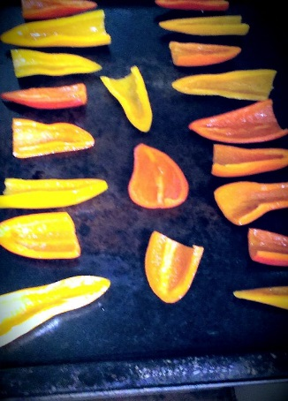
- Slice the tops of the peppers off and slice them in half lengthwise. Scoop out everything leaving just the beautiful skin and flesh. Place the seeded peppers in a large bowl.

- Toss the peppers with some olive oil and transfer them to a baking sheet skin side down. Put in the oven and bake for 7-10 minutes. (Minor charring on the bottom is ok) Remove them and set aside to cool for about 5 minutes.

- In a medium sized mixing bowl. Combine the cream cheese, ricotta, and shredded marble cheese. Stir together to combine.

- Add all of the next ingredients one at a time, followed by a stir to combine. Diced jalapenos, green onion, parsley, bread crumbs, garlic, and seal salt and pepper.

- Using a tablespoon, scoop the mixture into all of the peppers. You may have to use your fingers to aid in filling them. The peppers at this point are easy to work with so even pushing the sides open a bit and stuffing them will work.

- Return to oven on 400 F for about 8 – 10 minutes. (Look for browning on the top of the cheese) Remove and crack some sea salt over the tops of the peppers.

- Top with sliced green onions and serve.

