Garlic and Mozzarella Gnudi
Grocery List
- 475g light Ricotta cheese
- 2 cloves Garlic, grated
- Handful chopped fresh Parsley
- 1 egg, beaten
- ¼ C Garden Veggie Mozzarella
- Just under 1/3 C AP Flour
+ Some for dusting and rolling
- ½ Tsp. Sea Salt
- ¼ Tsp. Black Pepper

- 1 ½ C fresh Basil (approximately)
- 4 cloves Garlic
- Pinch Sea Salt
- EV Olive Oil

- 1 ½ Shallots, diced
- 1 Tbsp. unsalted Butter
- 1 – 2 Tbsp. EV Olive Oil

With a simple sauce of shallots, garlic, and basil
Prep Time: 15 – 20 Min
Chill Time: 2 Hr +
Cook Time: 20 Min
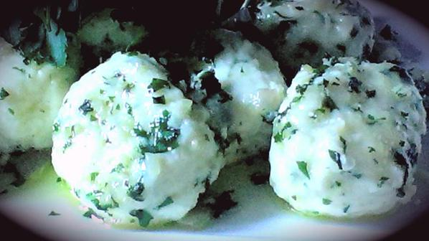

- In a medium sized mixing bowl, combine ricotta, grated garlic, parsley, mozzarella, salt, pepper, egg, and flour. Stir together to combine thoroughly. Have a small plate handy with some flour to roll the gnudi in. Roll about a half a tbsp. of the mixture in your hands to form balls and roll them in the flour. Transfer the gnudi to a baking sheet lined with parchment paper and dusted with flour. Chill for 2+ hours.

- Using a Food Processor, combine the basil, good pinch of sea salt, and garlic. Pulse to combine a few times and slowly pour the oil in while pureeing (about a ¼ C). Transfer basil mix to a small container and store in fridge until gnudi is ready.

- Get a large sauce pot out and fill ¾ the way full with cold water. Once it boils, add a generous amount of sea salt before adding the gnudi one by one. Stir the gnudi as you put them in to keep them from clumping. Boil 6 or 7 minutes. (depending on the size of your sauce pot you may need to do two batches) Transfer the gnudi to a plate lined with paper towel. Save the boiling gnudi water. Remove the paper towel and cover the gnudi.

- In a large frying pan, bring to temperature on medium heat. Combine the butter and olive oil and add in the diced shallots. Fry up 3 minutes or so and add in 2 Tbsp. of the basil mixture. Continue frying another 2 minutes stirring often. Add in the cooked gnudi and about a ¼ C of the boiling gnudi water. Season with sea salt and black pepper and stir the gnudi around to ensure they are coated on all sides. Cover and continue cooking 3 minutes.

- Transfer to a serving bowl and drizzle the basily oil all over the dish. Garnsih with fresh parsley and a nice pinch of sea salt and black pepper.

