Bean and Cheese Enchiladas
Grocery List
- 398 ml can Refried Beans
- ½ Roma Tomato, diced
- Red Onion, diced
- Jalapeno, seeded and diced
- 2 Green Onions sliced, white and light green separated from dark green slices
- 430 ml Green Salsa
- 6 Large Tortillas
- 127g can diced green Chilies
- 1 C shredded Cheddar Cheese
- 1 C shredded Monterey Jack Cheese
- Salt
- Olive Oil (for frying)

Prep Time: 20 Min
Cook Time: 40 Min

- Heat about 3 Tbsp Olive oil in a small saucepan on medium heat.

- Add in half the diced red onions and the jalapenos. Add a pinch of salt and fry for approximately 5 minutes.

- Add in the white and light green portions of the green onion as well as the tomatoes. Add in another pinch of salt and continue frying for another 4 minutes stirring occasionally.

- Add in ½ the diced chilies and the can of refried beans. Stir together and continue to heat on medium heat with the cover on for 5 minutes. Once thoroughly heated, the temperature can be reduced to low until you are ready to use the beans.

- Line the bottom of your baking dish with some of the green salsa.
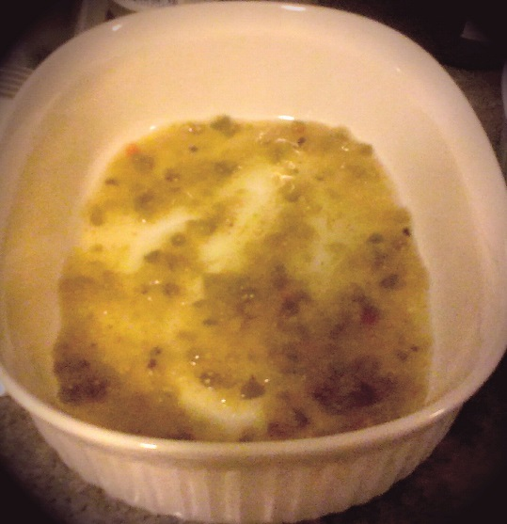

- Using a spoon, transfer the bean mixture evenly to your 6 Tortillas. Top with cheddar cheese and then roll both the sides into the middle and follow suit with the remaining two sides. Keep the folded side down when placing in the baking dish.
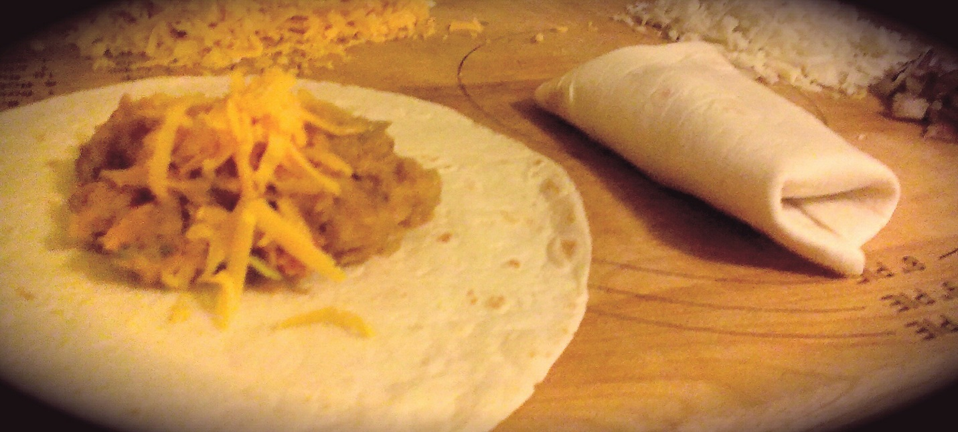

- Line the enchiladas in your 2 ½ Quart baking dish and smother with the remainder of the green salsa,
- Top with the remainder of the diced onions and chilies. Sprinkle the cup of Monterey all over the top and cover with a lid.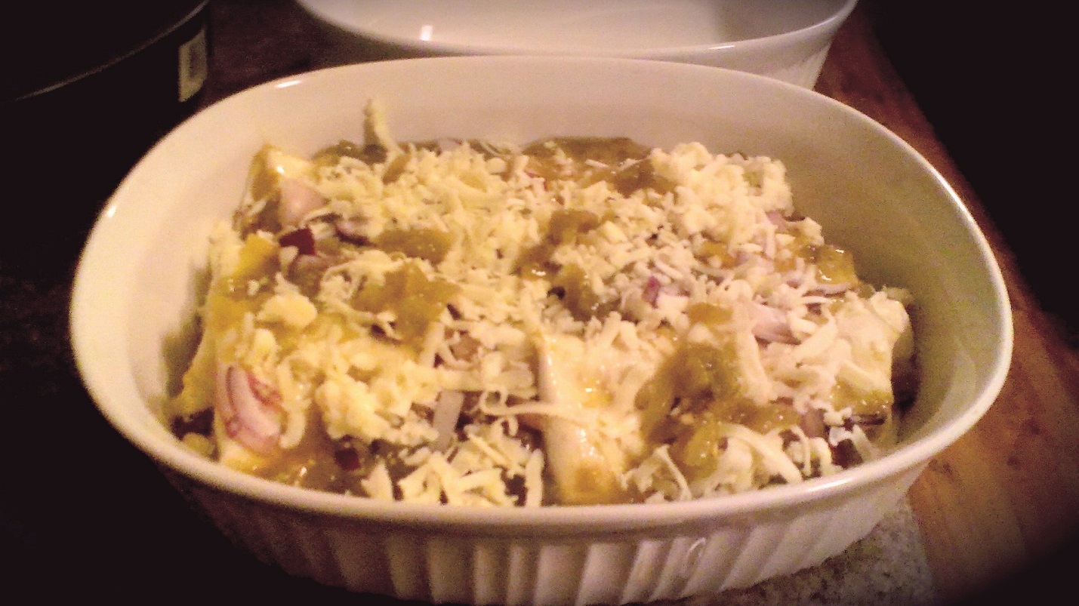

- Bake at 350 for 20 minutes, remove the lid and cook for another 20 minutes.

- Top with the dark green slices of green onion. For individual service. Garnish with cilantro, sour cream, and green onions. 