Jalapeno Black Bean Chili
Grocery List
- 3 Tbsp. Unsalted Butter
- 4 cloves Garlic, roughly chopped
- Red Onion, diced
- 3 Green Onions, sliced (light and dark parts)
- 3 Jalapenos, seeded and diced
- 1 Pint Medley Tomatoes
**Small and medium sized tomatoes halved and larger sized tomatoes quartered**
- 2x 540ml Black Beans, 1 can drained
- ¼ C Tomatillo Salsa
- ¼ C low sodium Vegetable Stock
- ¼ Tsp. Smoked Paprika
- 2 Tsp. Hot Sauce
- 2 Tsp. chopped fresh Cilantro
- Sea Salt / Black Pepper

- Green Onion / Shredded Monterey (Optional)

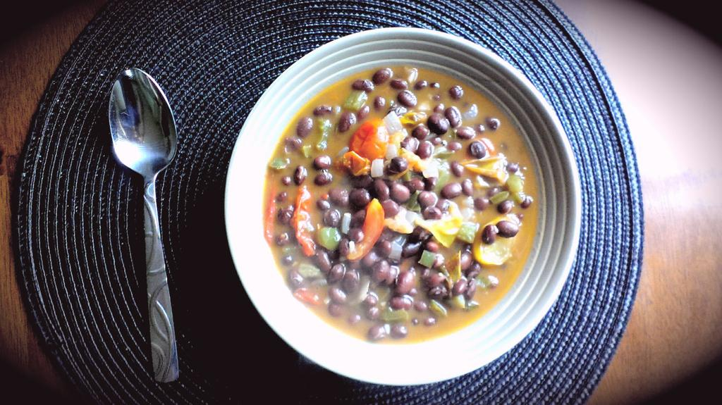
Prep Time: 10 Min
Cook Time: 45 Min +

- In a medium sized sauce pan, melt the butter on medium heat. Add in the garlic and fry 3 minutes stirring once.

- Add in the red and green onion and a pinch of sea salt. Stir often and cook 3 minutes before adding in the diced jalapenos. Continue cooking 2 or 3 minutes.

- Add in the tomatoes and another pinch of sea salt. Cook 5 minutes allowing tomatoes to cook down.

- Add in the tomatillo salsa, paprika, veg stock, hot sauce, cilantro, and black beans. Give a good pinch of sea salt and black pepper.

- Bring to a boil, reduce heat to medium low and cover. Simmer 30 + minutes.

- Remove lid 10 minutes prior to service to allow thickening.

- Serve garnished with sliced green onion. Finely shredded Monterey Jack cheese is delicious as well.

