Jalapeno Cheddar Buttermilk Biscuits
Grocery List
- 2 C AP Flour
- 1 Tbsp. Baking Powder
- 1 Tsp. Sea Salt
- ¼ Tsp. Baking Soda
- 1/8 Tsp. Sugar
- 6 Tbsp. Unsalted Butter, cold & shredded
- 1 C Old Cheddar Cheese, shredded
- 1 Jalapeno, seeded and diced
- 1 1/3 C Buttermilk

- EVOO Cooking Spray

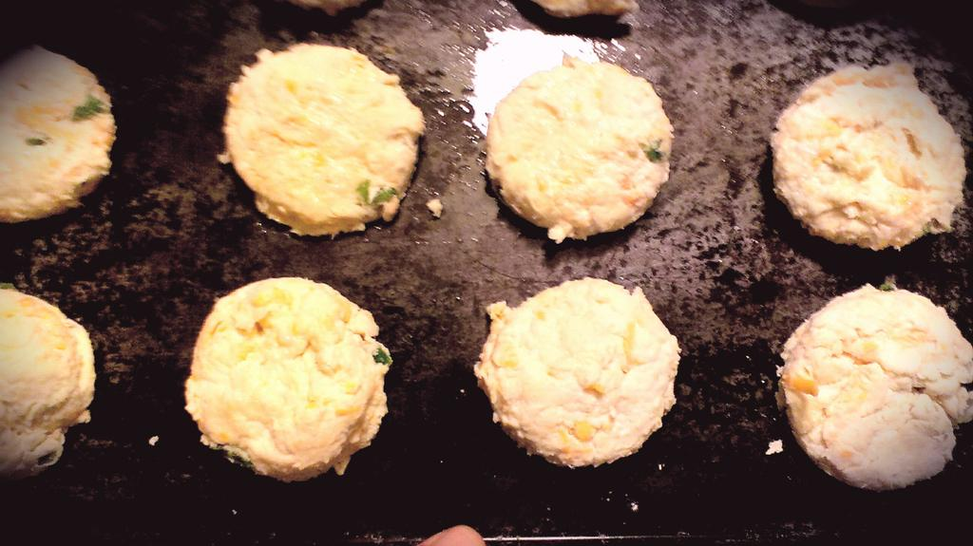
Prep Time: 10 Min
Cook Time: 12 – 15 Min
10 – 12 Biscuits

- Preheat oven to 450 F.

- Combine all dry ingredients in a large mixing bowl. Shred the cold butter into the dry mix and gently cut it into the flour using a pastry cutter. (A fork will do as well!)

- Add in the shredded cheddar and diced jalapenos. Stir gently to combine. Pour in the buttermilk and use a wooden spoon to slowly work the flour into the buttermilk. The dough should be fairly sticky (add buttermilk if needed), once combined transfer the dough to a floured surface and gently pat it out. Fold the dough over itself a few times and gently pat out once again.

- Use a biscuit cutter (A glass works great too!) to cut the biscuits. Once cut, transfer the biscuits to a baking sheet that has been lightly sprayed with olive oil spray. Place the biscuits on the tray evenly apart and spray them with the oil spray.

- Bake for 12 – 15 Minutes.

- Transfer to a wire rack to cool and serve.

