Spinach and Ricotta Lasagne Rollups
Grocery List
- 10 Lasagne Noodles
- 475g Ricotta Cheese
- 2 Cups Mozzarella shredded
- 3 cloves Garlic, minced / pressed
- Tbsp chopped Fresh Basil
- 2 Tbsp chopped Fresh Parsley
- Baby Spinach (About a Cup)
- Salt / Pepper
- Prepared Sauce (Approximately 4 Cups Prepared Sauce

Prep Time: 20 Min
Cook Time: 35 Min

- In a large saucepan, bring 4 L of water to a boil. Add the lasagne noodles and cover tilted for 6 – 8 Minutes. (Partially cooked, bendable) Strain and rinse.

- In a mixing bowl, add the ricotta, 1 cup Mozz, Parsley, Basil, Minced Garlic, salt / pepper and mix together.

- Line noodles on cutting board and spread approximately a Tbsp and a ½ of the ricotta mixture on and spread along the entire noodle.
- Top with spinach leaves across the entire noodle and roll from one end to the other.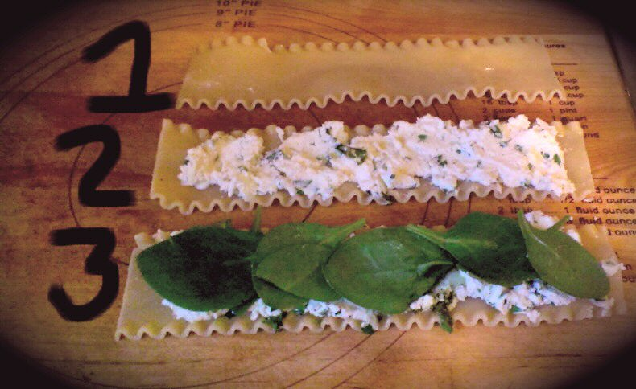

- In 2 separate 9 x 1 ½ Baking Dishes, line the bottom of each dish with prepared sauce. Place the rollups 5 in each dish and top with more sauce and the remaining CUP of shredded Mozzarella Cheese.

- Cover and Bake for 35 - 40 Minutes.

- Remove from over, serve with warm Foccacia Bread and Garnish with Fresh Parsley.

