Layered Bean Dip
Grocery List
- 1 398ml can Refried Beans*
- ½ 547ml can Black Beans, drained and rinsed
- 1 Red Onion, diced
- 10 grape Roma Tomatoes, quartered
- 3 Green Onions sliced thin (light and dark green)
- 1 Jalapeno, diced
- 1 ½ C Shredded Cheese **
- Tbsp Hot Sauce
- ¾ C Prepared Guacamole

Garnish
- Light Sour Cream
- Sliced Green Onions
- Hot Sauce (optional)
- Diced Tomatoes(optional)
*Read your beans, some refried beans contain lard! Look for ones made with vegetable oil / shortening.
** I shredded both Monterey jack and cheddar. You can however use a pre-shredded tex mex cheese.

Prep Time: 20 Min
Cook Time: 40 Min

- Heat about 2 Tablespoons oil in a small sauce pan on medium heat. Add in half the diced onions and a pinch of sea salt and fry for about 4 minutes. Add in the diced jalapenos (seeded or not, I usually slice them in half and remove one half of the seeds) and fry together for another 4 minutes.

- Add in the tomatoes and another pinch of salt and continue frying for 3 minutes. Add in the refried beans and stir everything together as the beans warm up. Reduce heat to medium low and cover for 15 minutes stirring occasionally.

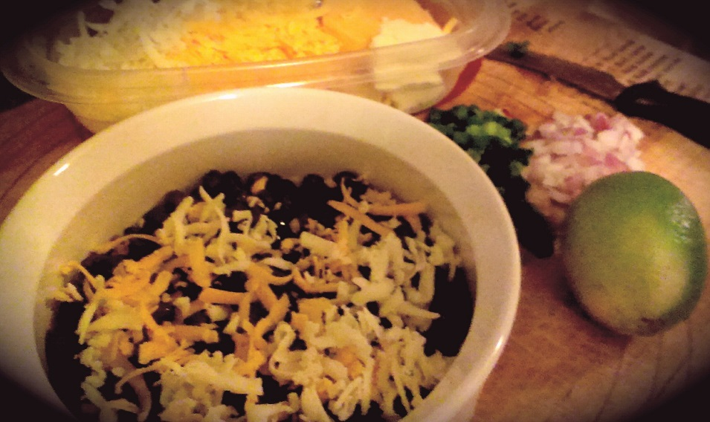
- In a 748 ml Circular baking dish, place the black beans in the bottom of the dish and top with some shredded cheese.

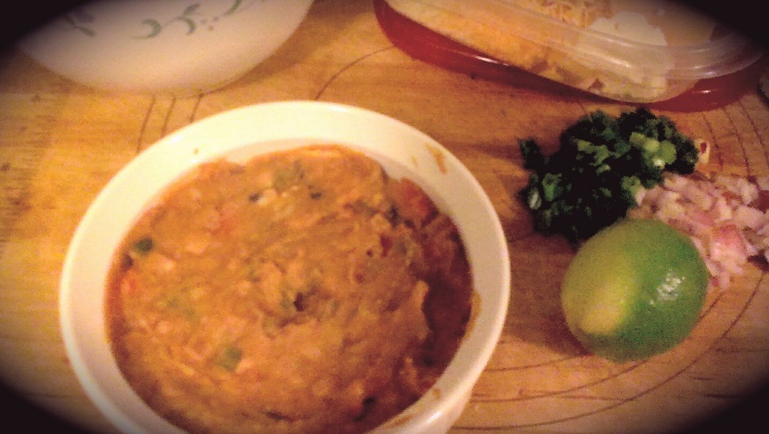

- Layer half the refried bean mixture on top of the black beans and use a spoon to evenly spread it across the dish.

- Next, spread your prepared guacamole evenly across the bean mixture. Top with a little more of the shredded cheese.

- Top the guacamole with the remaining bean mixture evenly spreading it across. Top with the remainder of the shredded cheese and diced onions.

- Bake for 20 Minutes at 350 F.

- Remove and garnish with dollop sour cream, sliced green onions, zest and juice of half a lime. Serve with your favourite tortilla chip.

