Leafless Greek Salad
Grocery List
- 2 Green Bell Peppers, cored and diced
- 1 Pint Grape Tomatoes
- ½ Red Onion, diced chunky
- ½ English Cucumber, sliced thick and quartered
- 10 + Olives, halved
- 200g Feta
DRESSING
- 1/3 C Red Wine Vinegar
- 2/3 C Extra Virgin Olive Oil
- 1 Tbsp Freshly chopped Oregano
- 1 Tbsp Freshly chopped Basil
- 2 Cloves Garlic, Minced or Pressed
- Sea Salt / Cracked Black Pepper
- 1 tsp Dried Parsley
- ½ Lemon, zested and juiced

Prep Time: 20 Min
Cool Time: 30 Min +
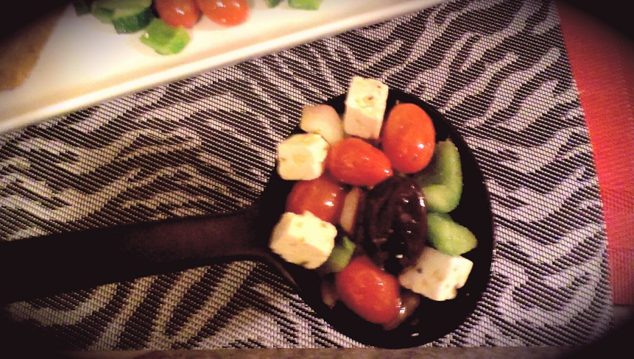

- Combine the peppers, olives, tomatoes, cucumbers, and chopped onions in a large mixing bowl.

- When working with Feta, it is usually packed as a large, thick disk of cheese. Slice the rounded edges off on all 4 sides so you are dealing with a brick instead.

- Cut the Feta into Cherry Tomato sized cubes and add to the diced vegetable mixture.

- In a separate bowl, combine the oil and vinegar and give it a stir. Add the minced garlic, herbs, zest and juice of the lemon and stir.

- Salt and pepper to taste, add in the parsley and whisk together.

- Pour about ¾ of the dressing on the salad and combine. Reserve the other 4th for service.

- Cool for atleast 30 minutes and serve.

