Meatless Moussaka
Grocery List
- 2 Eggplants, sliced ½ inch thick
- 8 Mini Red Potatoes, sliced
- EVOO
- Sea Salt / Black Pepper
- ½ Tsp. dried Oregano (potatoes only)

- ¼ C EVOO
- Yellow Onion, diced
- 3 cloves Garlic, chopped
- 340g YVES Italian Ground Round
- 796ml can Diced Tomatoes
- 1 Tbsp. Tomato Paste
- ½ Tbsp. Red Wine Vinegar
- ½ Tsp. Ground Nutmeg
- ½ Tsp. Dried Oregano
- ½ Tsp. Dried Parsley
- ½ Tsp. fresh Thyme
- ¼ C fresh Parsley, roughly chopped
- 1 C Baby Spinach, roughly chopped
- Sea Salt / Black Pepper

- 2 Tbsp. Unsalted Butter
- 2 Tbsp. AP Flour
- 1 C 2% Milk +
- ½ Tsp. White Pepper
- ½ Tsp. Ground Nutmeg
- Pinch Sea Salt

- ½ C Parmesan, grated

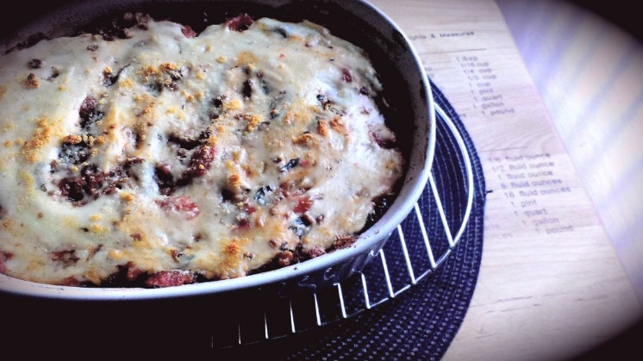
Prep Time: 20 Min
Cook Time: 1 Hr

- Preheat oven to 400 F

- Lay the sliced eggplant in one layer on a baking sheet that has been sprayed with EVOO / Baking spray. Drizzle with EVOO and season with sea salt and black pepper

- Same for the potatoes, drizzle and season with sea salt and pepper as well as add a ½ tsp. dried Oregano.

- Eggplant should bake between 20 – 25 and potatoes 25 – 30 Min. You want both to be nice and brown, flip at least once. Set aside to cool.
**Maximize time by preparing sauces while vegetables roast!!

- Reduce heat in oven to 375 F

- In a large frying pan, bring to temperature on medium and pour in the oil. Add the onions, garlic, and a pinch of sea salt. Fry 4 – 5 minutes stirring often.

- Add the veggie ground and break it up to a crumbly texture. Mix together with the onion and garlic and continue frying on medium 3 minutes.

- Stir in the tomato paste followed by the diced tomatoes, nutmeg, red wine vinegar, oregano, thyme, and sea salt / black pepper. Bring to a boil on medium and reduce to medium low. Cover and simmer 15 Minutes.

- Stir in the fresh parsley and spinach, reduce heat to low, and leave covered.

- In a small sauce pot, melt the butter on medium and whisk in the flour. Continuously stir the mixture so nothing burns. After 2 minutes of stirring, slowly whisk in the milk to break up any potential clumps. Bring to a boil stirring often. Season and reduce heat to low for 5 minutes.

- Spray a 2 ½ qt. baking dish with EVOO spray and begin lining the dish with the cooled, roasted eggplant. Follow with a layer of the roasted potatoes and a layer of the hearty sauce. Sprinkle with parmesan and complete another eggplant, potato, sauce & parmesan layer.
**Seal the remainder of sauce in an airtight container!

- Drizzle the Béchamel sauce through the middle of the dish from end to end. Use a spoon or spatula to gently press the béchamel away from the middle towards the edges. Sprinkle with the remainder of the parmesan and bake uncovered 25 – 30 Minutes.

- Cool 5 minutes before slicing in to.

