Mini Pepper Pinwheels
Grocery List
- 2 Large Tortillas
*I used Pesto and Garlic to give added flavour but you could use any coloured tortilla.
- 325g (approx.1 1/3 C) Cream Cheese
- 3 Mini Peppers, seeded and diced
*I tried to get one of each colour, (yellow, red, orange)
- 2 Green Onions, light and dark green parts, sliced
- 2 Tbsp. fresh Parsley, chopped
- Sea Salt / Black Pepper

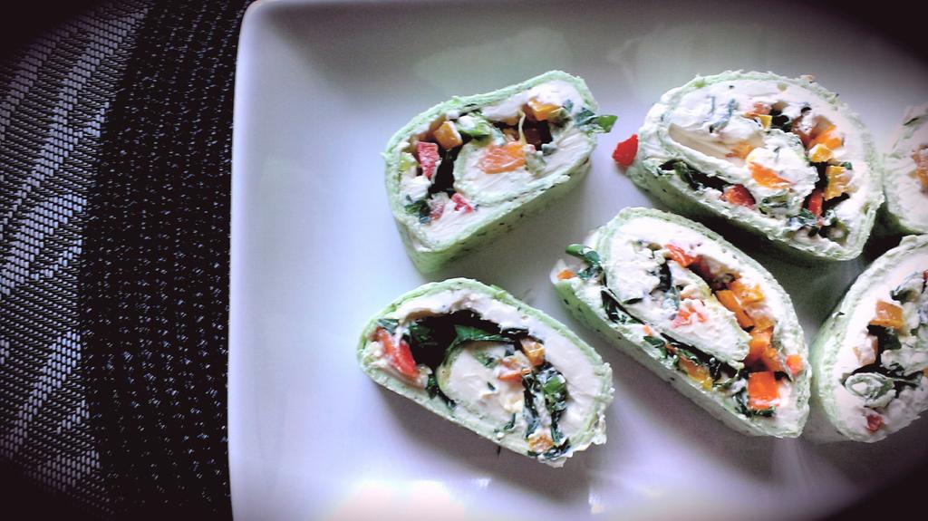
Creamy, rich, cream cheese is freshened up by a variety of mini sweet peppers and green onion and chilled.
Prep Time: 15 Min
Chill Time: 2 Hours

- Split the cream cheese between both tortillas. Spread from the middle and work out towards the edge. Once evenly spread, sprinkle the onions, peppers, and parsley evenly between both tortillas.

- Season each with sea salt / black pepper.

- Start from the bottom and roll towards the other end gently pressing down on the roll with each fold to compress it.

- Roll up in tinfoil and place in the fridge to cool for approximately 2 hours before slicing into.

- Makes approximately 16.

