Salsa Bean Scoops
Grocery List
- 20 – 25 Tostitos Scoops
- 2 Tbsp. EVOO
- 2 cloves Garlic, chopped
- 1 C mix of onion (red diced, yellow diced, green sliced)
- 1 Tbsp. Prepared Salsa
- 398ml can Refried Pinto Beans
- Sea Salt / Black Pepper

- 1 Green Onion, sliced
- ¼ C Sharp Cheddar Cheese, cut into approximately ¼ inch cubes

Prep Time: 15 Min
Cook Time: 20 Min
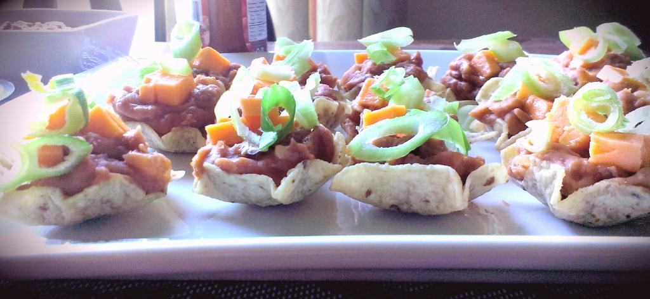
- Bring a medium sized saucepan to temperature on medium and pour in the EVOO. Next, add the garlic and stir often for 2 minutes before adding the onions and a pinch of sea salt / black pepper, Continue cooking stirring often for 4 –5 minutes. Spoon in the salsa and stir to combine. Cook another minute.

- Stir in the beans and bring to a bubbling state before reducing heat to medium low and covering for 10 minutes. Remove from heat.

- Use a teaspoon to spoon the mixture into the scoops. About a tsp. per scoop. Top with cheddar cubes and sliced green onion.

- Serve with a dipping station with your favourite salsas, guacamole, and hot sauces.

