Sinfully Spicy Salsa
Grocery List

- 5 Roma Tomatoes, quartered
- 2 Jalapenos, halved (only 1 seeded)
- 2 Cloves garlic
- 2 Green Onions, sliced and separated white and light green from dark green
- 1 Lime, zest and juice
- ½ C lightly packed Cilantro
- Red onion, peeled and quartered
- 127 ml can green chilis
- Sea Salt / Pepper

Prep Time: 10 Min
Cook Time: - - -
Serves 4-6
NOTE: FOOD PROCESSOR
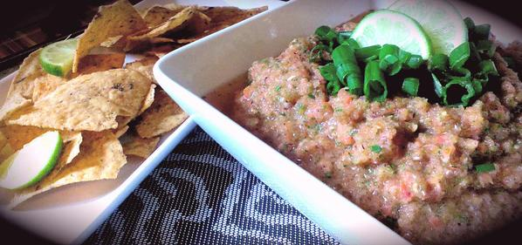

- With the food processor running, drop in the red onions, garlic, white and light green portions of green onions, and jalapenos. Turn off.

- Put in the cilantro, chilis, lime zest and juice, sea salt and pepper to taste ( I used two full rotations with the grinder for sea salt and 3 or 4 dashes of pepper. Adjust if needed)

- Pulse manually a few times to blend and dump in the rest of the tomatoes. Pulse until thoroughly blended. Transfer to a serving bowl and garnish with fresh cilantro, the dark green portions of the onions, and a few lime wedges.

- Serve with your favourite tortilla chip or use in burritos, tacos, and more!

