Spinach Pesto Calzone
Grocery List

DOUGH
- 1 C warm Water
- 1 Tsp. Instant Yeast
- 1 Tsp. Sugar
- 2 C A.P. Flour
- 1 Tsp. Sea Salt

SPINACH PESTO
- 4 C Spinach, lightly packed
- 5 cloves Garlic
- 1/3 C Pine Nuts
- 1/4 C EV Olive Oil
- Handful fresh Parsley
- 1 Tbsp. grated Parmesan
- 1 Tsp. Sea Salt

“TOPPINGS”
- 2 C Spinach, larger leaves chopped
- 2 Roma Tomatoes, sliced
- ½ Red Onion, diced
- Fresh Parsley
- 12-15 slices Mozzarella (Brick variety)

With Spinach, Tomatoes, Onions, Mozzarella, and Fresh Parsley.
Makes 3
Prep Time: 30 Min
Cook Time: 25 Min
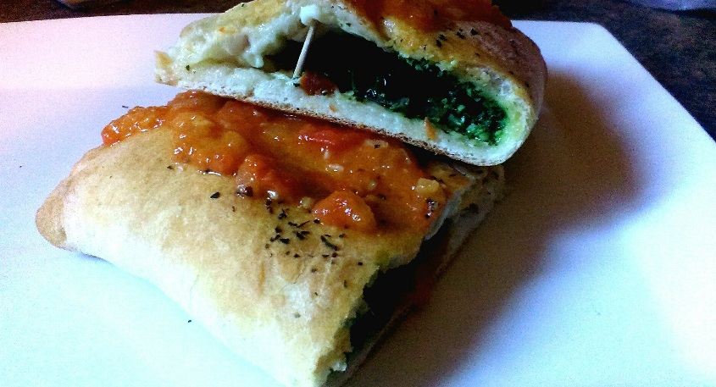
DOUGH
- In a large bowl, combine the water, yeast and sugar. Leave for between 5 – 6 minutes until foamy on top.
In a FOOD PROCESSOR, combine the flour and salt, slowly pour the watery mix into the processor. Continue running until a soft dough has formed.
Knead a few times on a floured surface and roll into a ball shape. Place the dough in a lightly oiled bowl and cover with a dry cloth or towel. Allow to rise approximately 30 Minutes.

- Using the FOOD PROCESSOR, combine the 4 C spinach, garlic, pine nuts, and parsley. Pulse to combine. Add in the salt and parmesan. Continue running and slowly pour in the oil. Transfer to a bowl.

- Preheat oven to 400 F.

- Slice the chilled dough into 3 equal parts and roll out using a rolling pin until
The dough is the same size as an 8” Tortilla. Take 2 generous Tbsp. of the Pesto and spread straight down the middle (east to west) leaving an inch from each side.
Top with spinach leaves, tomatoes, diced onion, parsley, and 4 or 5 slices mozzarella. Drizzle with olive oil.

- Fold the North point over to meet the South. Use a knife to trim excess dough and crimp the edges across the fold. Make 3 diagonal slices across the top, drizzle with olive oil, and a of sprinkle dried basil. Bake for approximately 23 – 27 Min until golden brown.

SERVE WITH TOMATO SAUCE

