Spring Veg Potato Salad
Grocery List
- 8 Russet Potatoes (about 4 ½ C diced)
- ¼ C diced Red Onion
- ½ C diced English Cucumber
- ½ C diced celery
- ¼ C diced Red Pepper
- ¼ C fresh Parsley, roughly chopped
- ¼ C light Miracle Whip
- ½ C Mayonnaise
- 1 Tbsp. White Vinegar
- 1 Tbsp. chopped fresh Chives
- Smoked Paprika
- Sea Salt / Black Pepper

Prep Time: 10 Min
Cook Time: 20+ Min
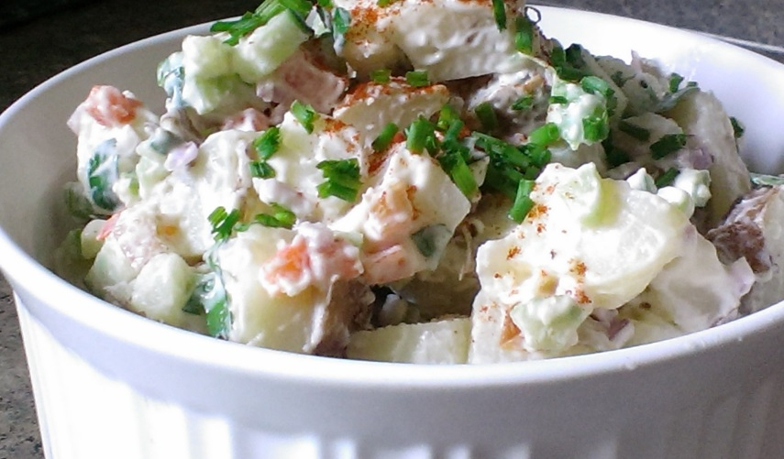
- Thoroughly scrub the potatoes and place them in a large sauce pan filled with lightly salted water. Bring to a boil and cook with the lid tilted for approximately 20 minutes. (Pierce the potatoes after 16 or 17 minutes with a fork to ensure they are cooked but not mushy) Strain and cool.

- Slice the potatoes in half lengthwise and each half in half lengthwise as well. Dice from here.

- In a small mixing bowl, combine Miracle Whip, Mayo, vinegar, and a pinch of sea salt and cracked black pepper. Stir to combine.

- In a large mixing bowl, combine half the diced potatoes with half of all of the diced veggies, half the creamy mayo mixture, half the chopped parsley, and a generous pinch of sea salt / pepper. Gently toss together before layering with the remainder of the potatoes, veggies, parsley, and mayo mixture. Add another pinch of sea salt and pepper and gently stir to combine once more.

- Top with the chopped chives and a sprinkle of smoked paprika. Enjoy immediately or cover and cool for an hour allowing the flavours to really blend together.

