Summer Garden Pasta Salad
Grocery List
- 454 g box Rigatoni
- ½ pint. Grape Tomatoes
- ½ English Cucumber, halved and sliced
- 2 stalks Celery, sliced
- 2 sweet Mini Peppers, seeded and sliced
- 2 Tbsp. Fresh Parsley, chopped
- ½ Tsp. dried Basil
- Sea Salt / Black Pepper
- 1 Lemon, zested

VINAIGRETTE

- 1/3 C EVOO
- 1 ¼ Tbsp. White Vinegar
- 1 clove Garlic, crushed and pressed (or finely minced)
- 1 Tbsp. fresh Parsley, chopped
- ½ Tsp. Sea Salt
- ¼. Tsp Black Pepper
- ½ Tsp. Dried Parsley
- ¼ Tsp. Dried Oregano
- ¼ Tsp. Dried Basil
- Pinch of crushed Red Pepper Flakes
- ¼ Lemon, juiced

Dressed in a fresh Italian style Vinaigrette

Prep Time: 15 Min
Cook Time: 12 – 14 Min
Chill Time: 1 Hr+
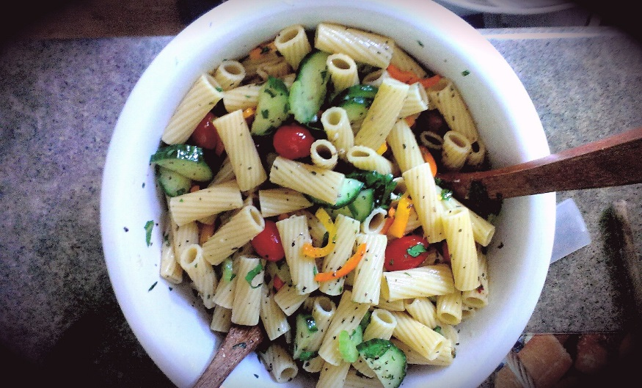
- Bring a large saucepan filled with cold water to a boil, generously salt and add the pasta. Cook to al dente approximately 12 – 14 min and strain. Rinse with cold water to cool down.

- In a small mixing bowl, combine all ingredients for dressing and whisk together. Set aside.

- Transfer the noodles to a large mixing bowl. Add in the vegetables one at a time, giving a pinch of both sea salt and black pepper and tossing before adding the next vegetable. Once all your veggies are tossed into the salad, add in the fresh parsley, lemon zest, dried basil, and dried parsley and one last pinch of sea salt and black pepper.

- Drizzle half the vinaigrette over the salad and toss before finishing off the dressing and tossing once again. Taste and adjust the salt and pepper. Cover and cool in the fridge for at least an hour before serving.

