Tomato Salad “Pitza”
Grocery List
- 4 Greek “Pocketless” Pitas
- 1/3 C EV Olive Oil
- 2 cloves Garlic, pressed / minced
- 1 Tbsp. fresh Oregano
- 12 Tbsp. light Ricotta cheese
- 16 Medley Tomatoes, halved
- ½ Red Onion, diced
- 2 fresh Basil leaves, rolled up and sliced
- ½ C fresh Parsley, roughly chopped
- 1 C Baby Spinach, excess stems removed
- 16 Bocconcini
**cherry tomato sized
- Sea Salt, Black Pepper

Prep Time: 15 Min
Cook Time: 12 - 15 Min
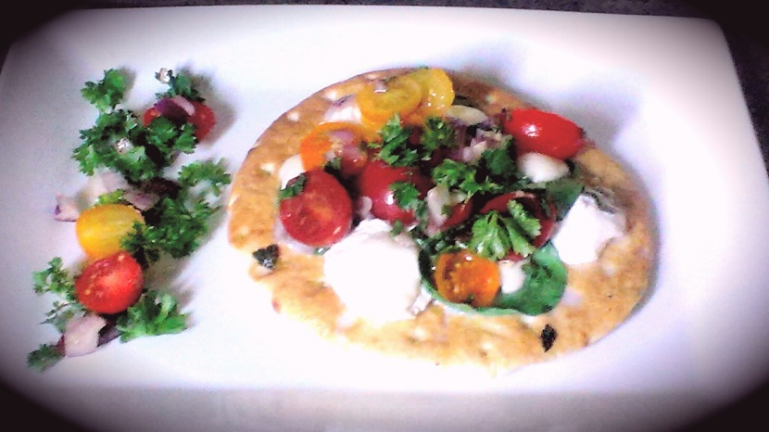
- Preheat oven to 425 F.

- In a small bowl, pour in the olive oil and add garlic, a pinch of sea salt and black pepper. Stir to combine.
Using a brush, brush each pita with the garlicy oil and transfer to an ungreased baking sheet.

- Top each “pitza” with 3 Tbsp. ricotta. Add a pinch of sea salt to each pita and transfer to oven for approximately 5 or 6 minutes.

- In a small bowl, combine the halved tomatoes, red onion, chopped fresh basil, and 2 pinches Sea Salt / 1 Pinch Black pepper. Pour the remainder of the garlicy oil over the tomato salad and stir to combine. Set aside.

- Remove the pitzas from the oven and sprinkle the oregano evenly between them. Line each pitza with 4 or 5 spinach leaves and 4 Bocconcini each. Give another pinch of salt and back into the oven for another 5 or 6 minutes.

- For service, give 2 heaping Tbsp.’s of the tomato salad mixture to each pitza and sprinkle the fresh parsley over them.

