Veggie Pot Pie
Grocery List
- 1/3 C Unsalted Butter
- 1/3 C All Purpose Flour
- 1 Yellow Onion, diced
- 1 Celery Heart, diced
- 2 Carrots, peeled and sliced thin
- 2 ½ C Diced Russet Potatoes
- 1 C Chopped Broccoli
- 1 clove Garlic, minced
- 1/3 C Frozen Peas
- 1 ¾ C Low Sodium Vegetable Stock
- 1/3 C 2% Milk
- 1/3 C Whipping Cream
- 1 Tbsp. chopped Rosemary
- 2 Tbsp. chopped Parsley
- Sea Salt, Pepper

DOUGH
- 1 C All Purpose Flour
- 1 ½ tsp. Baking Powder
- ¼ Tsp. Salt
- 3 Tbsp. Unsalted Butter
- 1/3 + C Milk

Prep Time: 30 Min
Cook Time: 50 Min
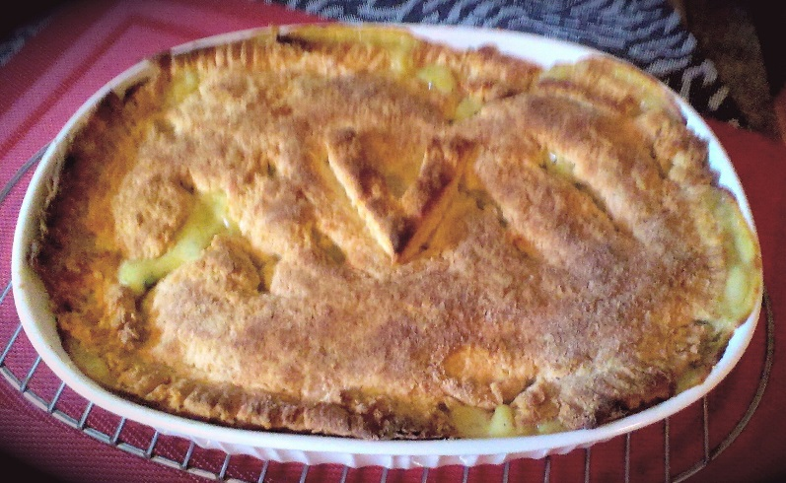

- In a medium sauce pan, melt the butter on medium low heat. Add the onion, garlic, carrots, celery, and a pinch of sea salt. Fry 8-10 minutes stirring periodically.

- In a separate medium saucepan, bring 4 Cups cold water to a boil on medium high heat. Add in the diced potatoes and boil for about 6 minutes before adding the chopped broccoli, boil another 5 minutes. Strain and set aside.

- To the vegetable mixture, stir in the flour and add a teaspoon of sea salt and a ½ a teaspoon of black pepper. Stir together frying on low medium for another 5 minutes or so.

- Remove from heat and whisk in the vegetable stock, milk, and cream. Return to heat and adjust to medium. Add the chopped parsley and rosemary. Bring mixture to a boil stirring constantly until mixture thickens.

- Reduce heat to low and stir in potatoes, broccoli, and frozen peas.

- Preheat oven to 425 F.

- In a small mixing bowl, combine the dry ingredients for the dough. Cut in the butter to the flour mixture. Slowly pour the milk into the mix starting with 1/3 a cup, if the dough is a little crumbly add a little more milk slowly until the dough is a bit more together.

- Transfer to a floured surface and knead about 8 or 9 times and begin rolling the dough out to the shape of your preferred baking dish.

- Transfer the creamy vegetable mixture to a 1 ½ qt baking dish. Place the dough over top the dish and use a knife to trim the excess dough around the edge. Use a fork to crimp the edges.

- Bake for 30 minutes.

- Remove from oven and cool for 6-7 minutes before service.

