White Bean and Basil Dip
Grocery List
- 540 ml can Cannelini Beans. Drained and rinsed
- 2 cloves Garlic, crushed
- 2 Tbsp. diced Red Onion,
- 6 stalks Parsley
- 7 – 9 Basil leaves (depending on size) (approximately 2 Tbsp. Chopped)
- Approx. ¼ C EVOO
- Sea Salt / Black Pepper
- ½ Tsp. Dried Basil
- 1/3 Tsp. Dried Parsley

Prep Time: 10 Min
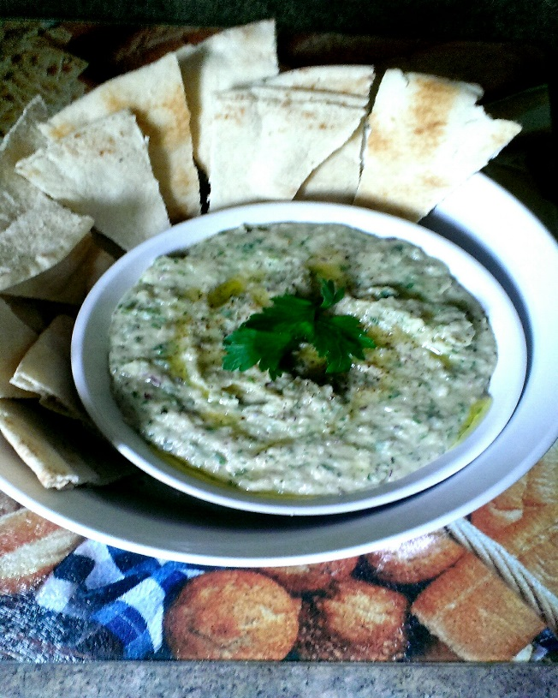

- Using a food processor, pulse the onion and garlic together a few times to begin chopping them up. Add in the fresh parsley and basil and pulse another 3 or 4 times to chop and combine.

- Add the beans, dried herbs, and a good pinch of sea salt and black pepper (about ½ Tsp. Sea Salt and a tiny bit less for the Pepper) Pulse until the beans are virtually mashed.

- With the processor running, slowly pour in the EVOO until the dip is the consistency that is preferred (about ¼ C)

- Adjust seasoning. Transfer to a serving bowl and drizzle with EVOO. Garnish with fresh Parsley. Enjoy with Pita bread, pita crisps, or crackers.

