Zucchini Penne Bake
Grocery List
SAUCE

- 1 C Extra Virgin Olive Oil
- 796 ml can Diced Tomatoes
- 1 Yellow Onion, diced
- 3 cloves Garlic, roughly chopped
- 1 medium sized Carrot, peeled and diced
- 1 Celery heart, diced
- ½ C fresh Parsley, roughly chopped
- ¼ C fresh Oregano, roughly chopped
- 1 Tsp. Sugar
- Sea Salt / Pepper

Ricotta Mix

- 475g light Ricotta Cheese
- ½ Red Onion, diced small
- 2 cloves Garlic, pressed
- 3 Tbsp. chopped Parsley
- 1 Tbsp. chopped Basil
- Sea Salt / Pepper

- 454g (about 5 cups) Penne Rigate
- ¾ C light Sour Cream
- 6 Slices Provolone cheese
- 1 C shredded Mozzarella
- 1 Zucchini, sliced

Prep Time: 25 Min
Cook Time: approx. 1 Hr

Sauce
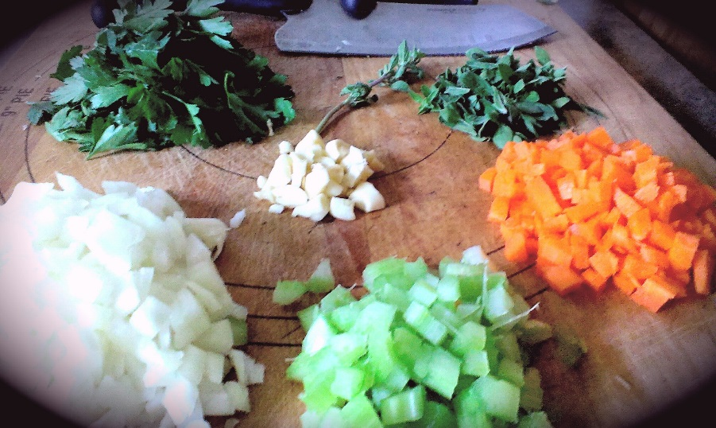
- In a large saucepan, heat the olive oil on medium. Add in a pinch of fresh oregano and the chopped garlic. Cook for 2-3 minutes stirring often.

- Add in the onion, celery, and carrot and a few pinches of sea salt. Fry everything together stirring often for about another 5-8 min.

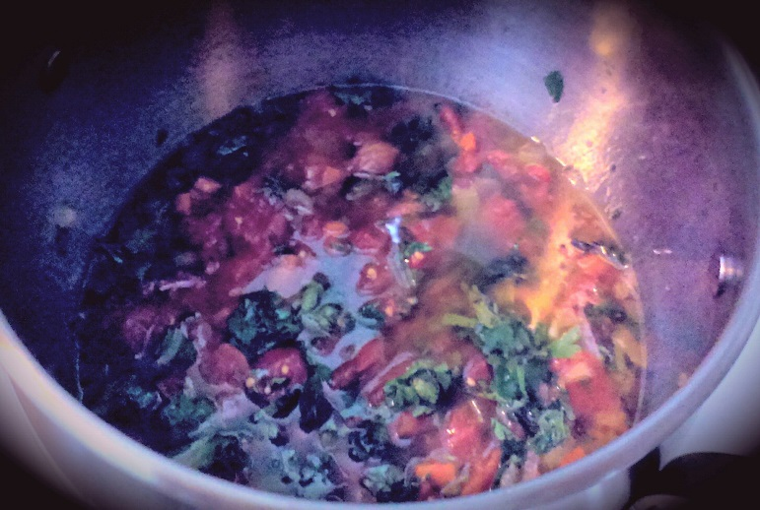
- Add in the tomatoes and herbs and stir to combine. Bring to a boil and reduce heat to medium low, cover and simmer 15 – 20 Min.

- Using an immersion blender, blend until smooth. Season with sea salt and pepper, taste and adjust if necessary.

- Remove from heat and leave covered until ready to use.

- In a large saucepan, bring 4 – 5L of cold, salted water to a boil. Add the pasta and cook until al dente. Follow the package directions. Strain and set aside.

- Preheat oven to 350 F

- Prepare the Ricotta mixture by combining all ingredients and mixing with a fork. (You can do this part ahead of time and refrigerate covered until ready to use)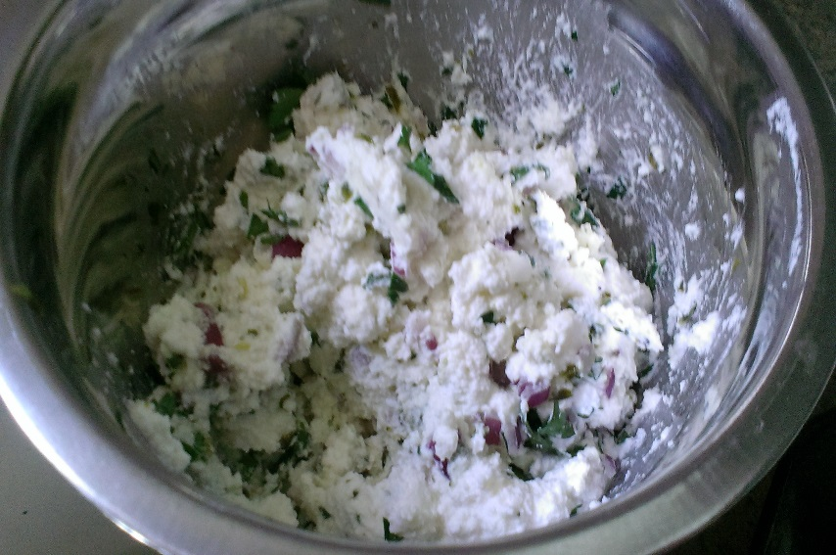

- Drizzle a 13 x 9 baking dish with olive oil and rotate the dish to spread it around. Start by layering the dish with half the cooked penne. Next you will layer half of all the following; Ricotta Mix, Provolone, Sour Cream, shredded Mozz, and sliced zucchini.
(For sour cream and ricotta, you will be dolloping across the dish sporadically to ensure every area ends up with a little)
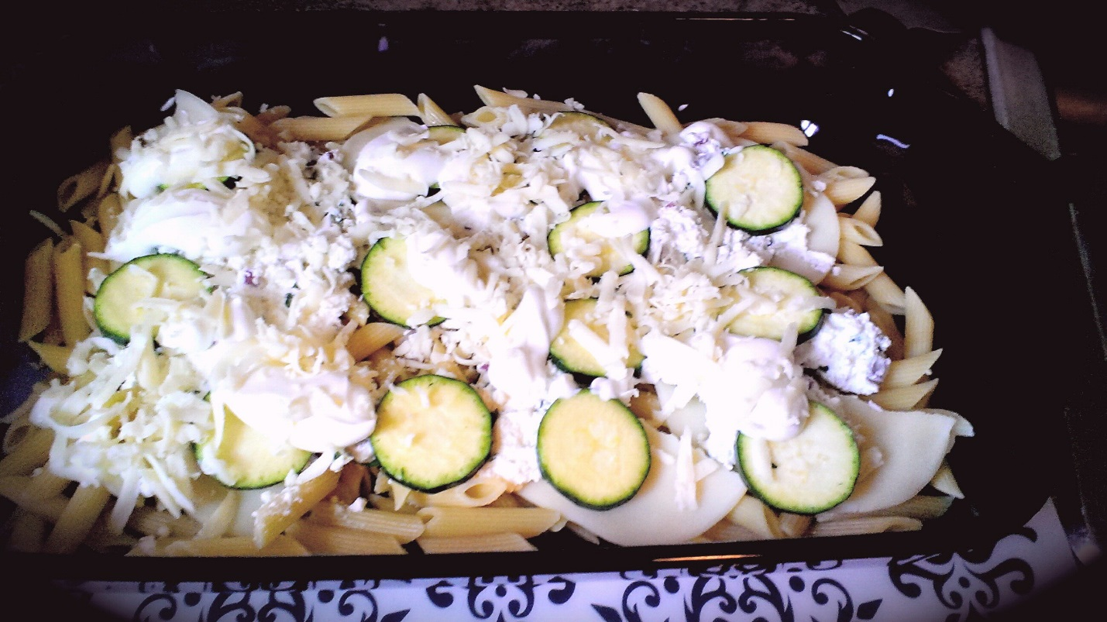

- Ladle sauce all across entire dish coating everything and begin with the final layer. Remainder of noodles, ricotta, provolone, mozz, sour cream, and zucchini slices. Ladle more sauce across the top.
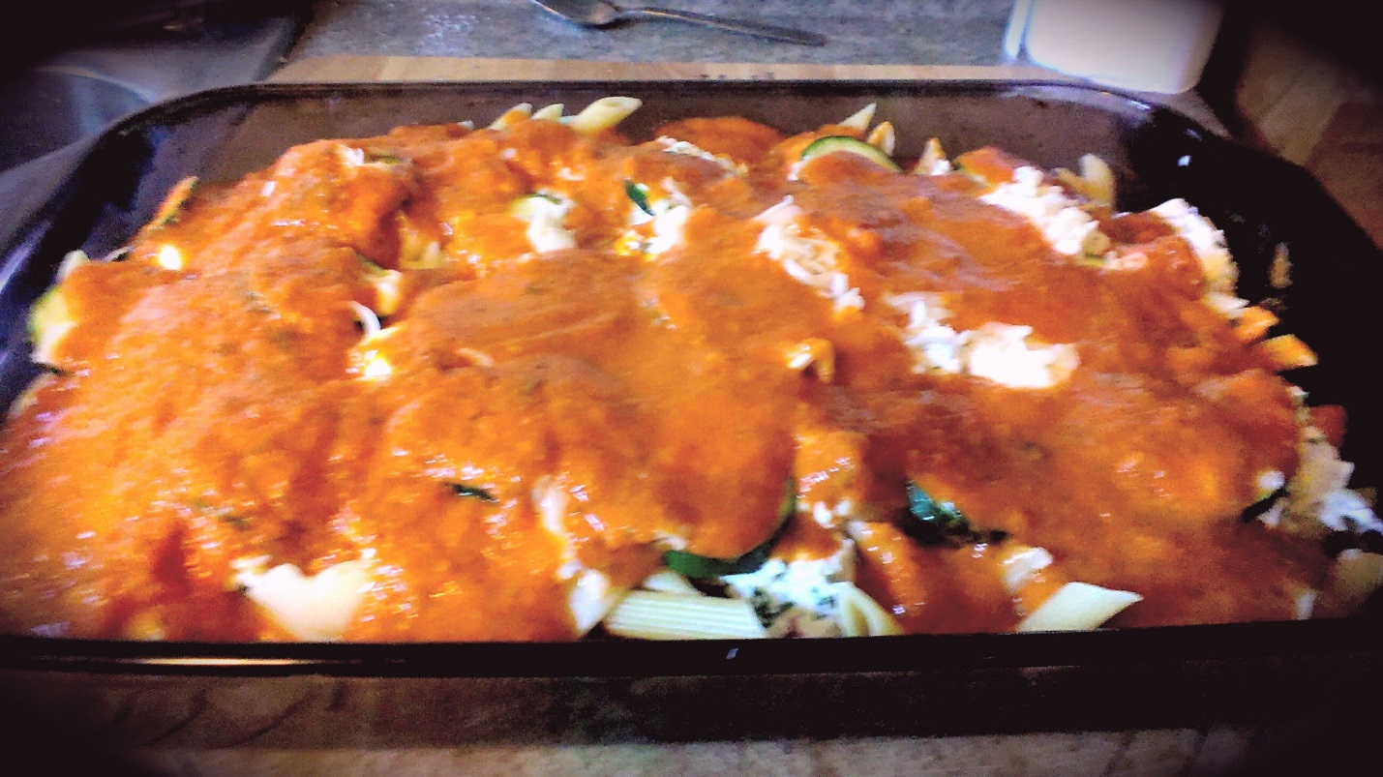

- Bake uncovered for 23-28 minutes.

- Remove and allow to cool for about 10-15 minutes before cutting into.

- Top with freshly chopped Parsley.

